**Assignment 8.2**

**Write a hive UDF that implements functionality of string concat_ws(string SEP, array). This UDF will accept two arguments, one string and one array of string. It will return a single string where all the elements of the array are separated by the SEP.**

Sol:

Java code to return all elements of the array separated by separator.

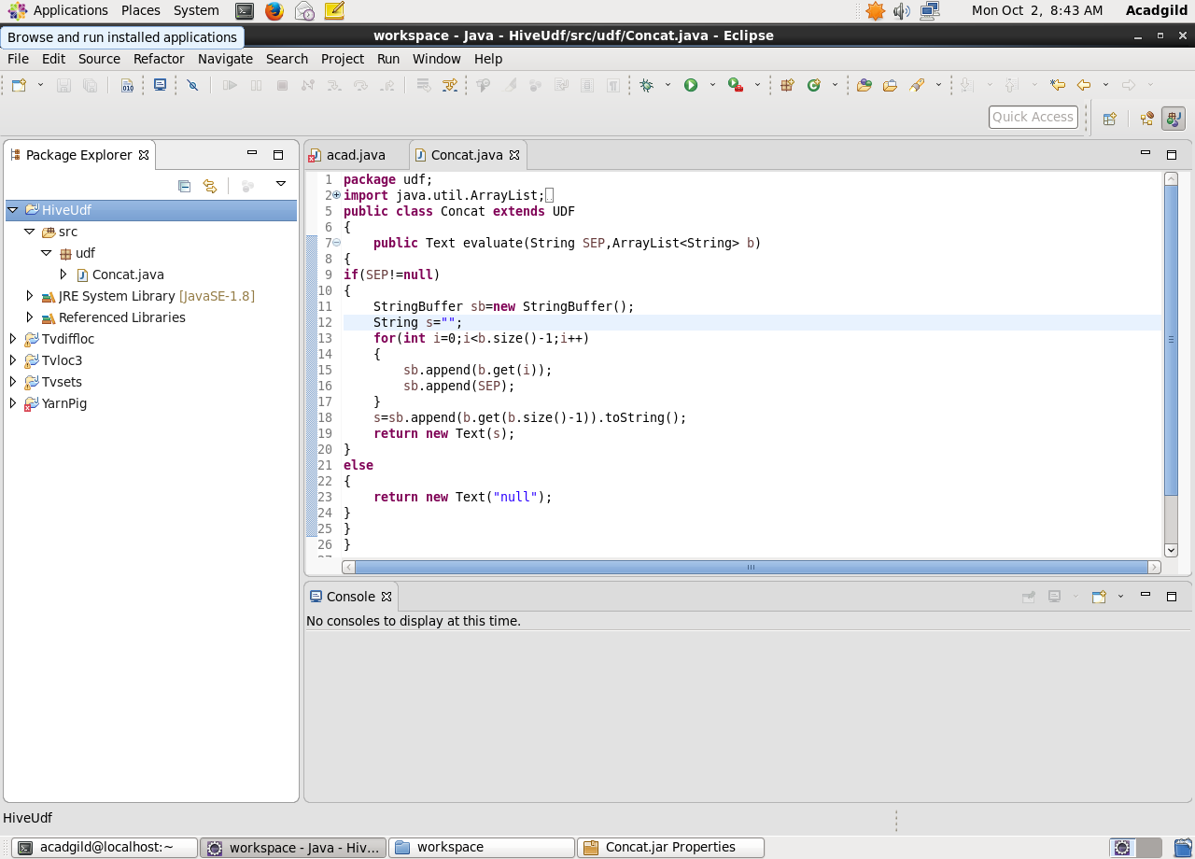

Here, adding the jar file and creating the table named as ‘**Concat**’

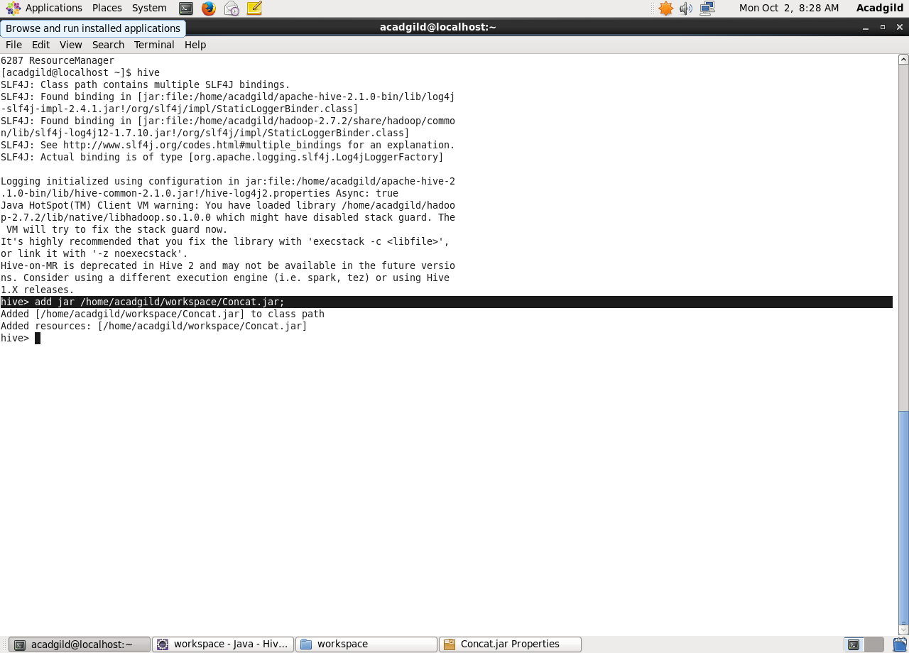

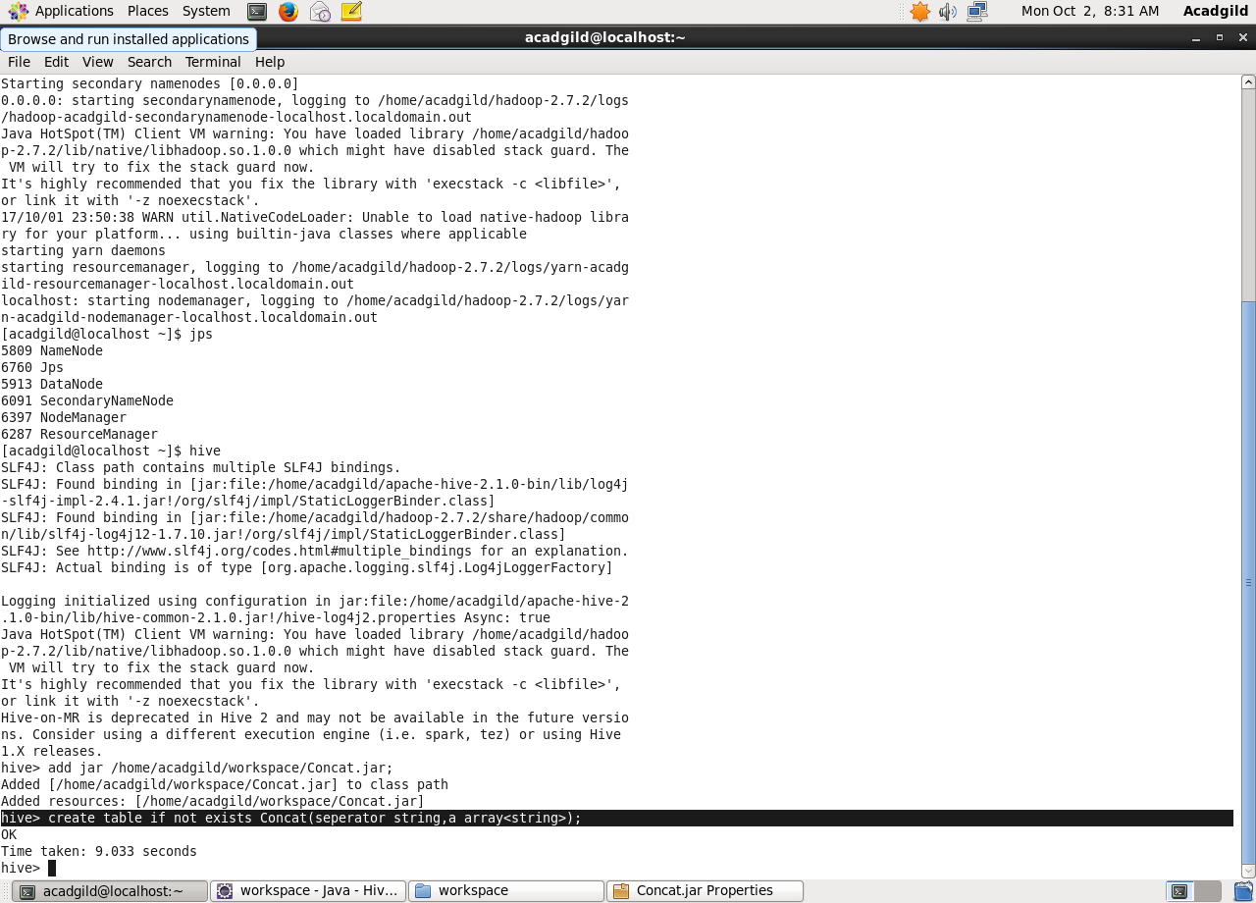

Creating temporary function ‘Hivudf’ then inserting the data into the created table ‘Concat’ using insert function.

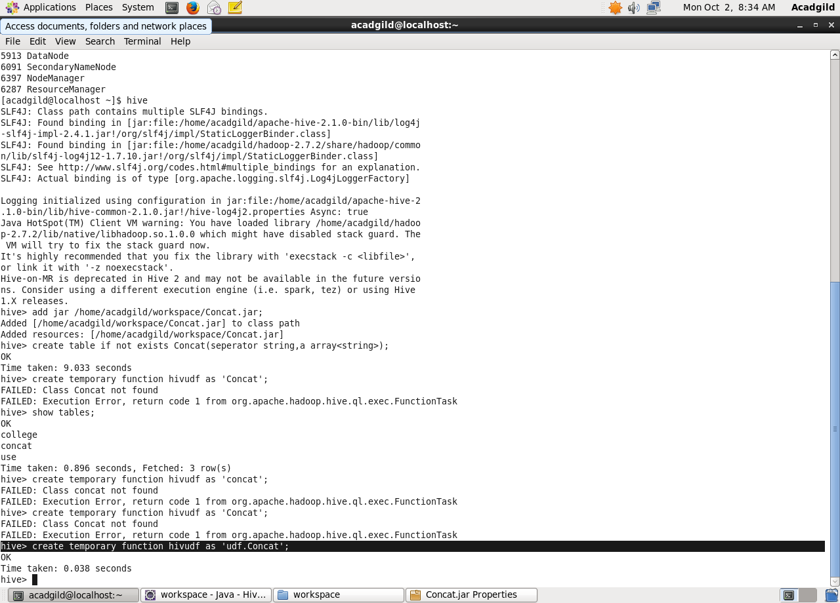

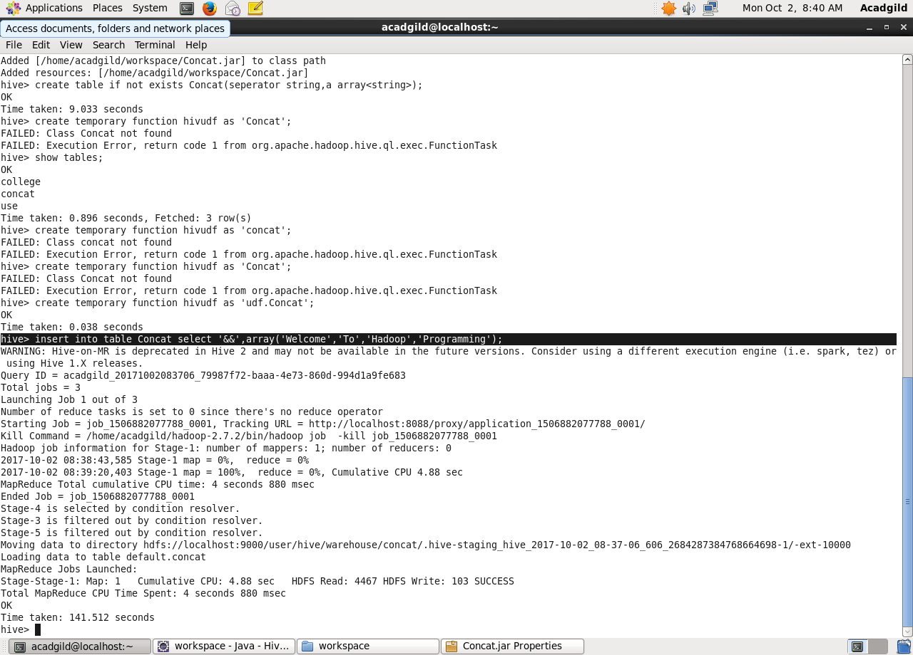

Select from table(concat)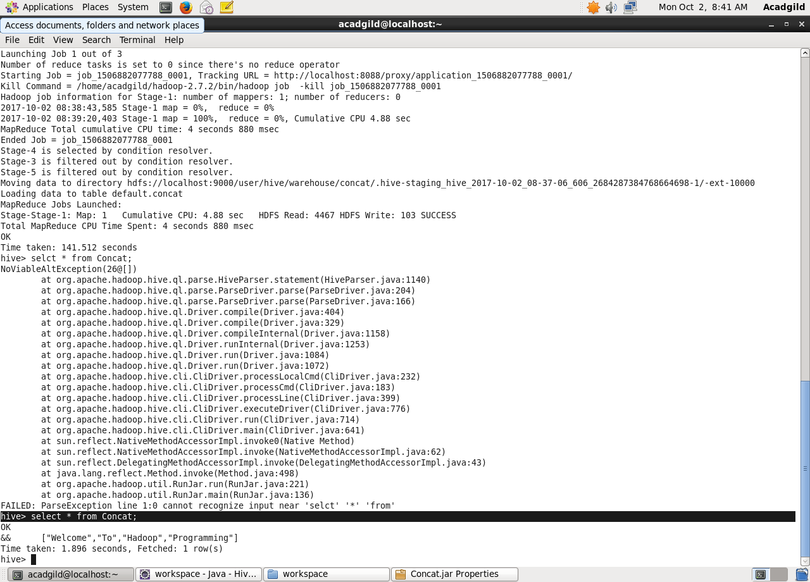

Retrieving the data using temporary function

